6. Crouch Lift
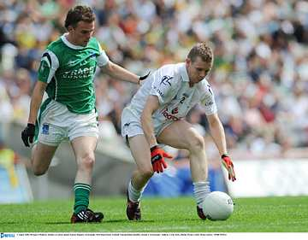

- Introduce
- Demonstrate
- Execute
- Attend

Move to the ball

The Crouch Lift is a basic skill in Gaelic Football used to lift the ball from the ground into the hands.

Place hands in front of the ball

Look out for:
- Not crouching to lift the ball
- Not placing the hands in front of the ball
- Touching the ball on the ground
- Not planting the support foot beside the ball

Scoop the ball forward into the cupped hands

Secure possession
Pg. 73-78 FFD

Crouch Lift

Practice the Technique


Lift and Drop
Player jogs forward to Crouch Lift the ball, places the ball at the next marker and continues on

Bridge Ball
Player rolls ball between partner’s legs and runs on to Crouch Lift it as it moves away.


Tussle and Lift
Coach rolls the ball forward for each pair to chase and contest

Develop the Skill


Scatter and Lift
Attackers try to crouch lift as many balls in 30sec while the defenders try to oppose them.
Grid Swap
Each team in turn Crouch Lifts all the balls into their grid



